Friday, April 22 2016, following our 'too late in the afternoon' foray up the Cream Track a couple of weeks ago, I led a crack team from Friends of Currumbin and the Mid Week Walking Group up the Cream Track from Tallebudgera Creek Road to 'survey the Survey' i.e. complete our own survey of the recent Gold Coast Council Cream Track Survey, so that we may offer a well researched report to the relevant GCCC officers. Our target area is the lower half of the Cream Track up from TC Road and through the sections flanked by private property until we reach the safely un-contentious National Park zone. And this time we started at a more sensible 10 AM, supported by a Garmin 64ST GPS with the Aust/NZ topo maps chip loaded.

I can report that from a public access point of view, "going up" has improved, but only slightly - specifically:

(1) the new pedestrian friendly gate at the top end of Tallebudgera Creek Road is a very welcome change from the old 'Private property No entry' model. So a good start then.

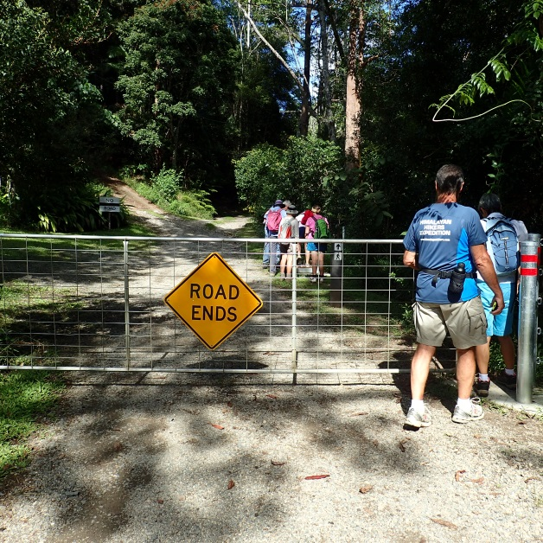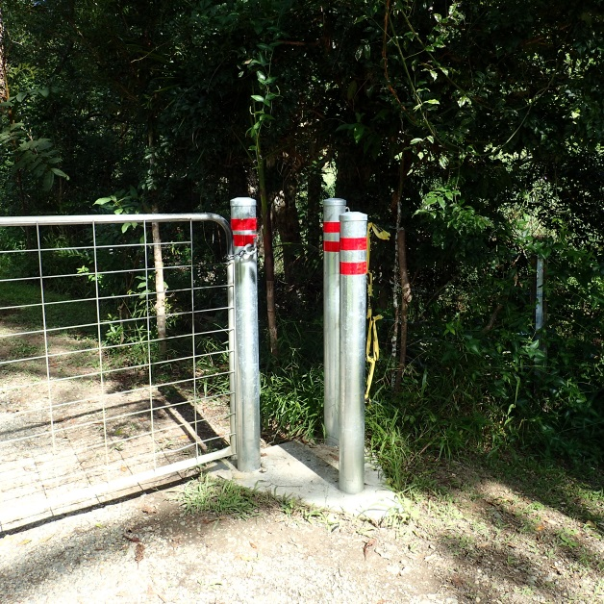

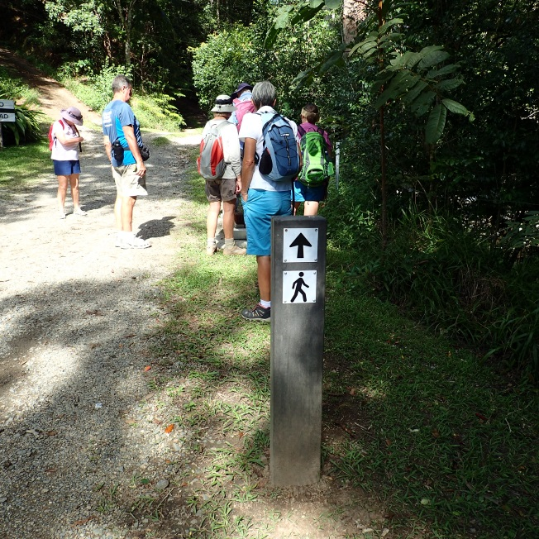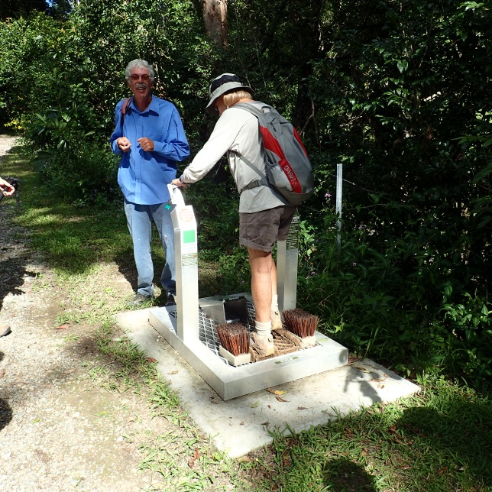

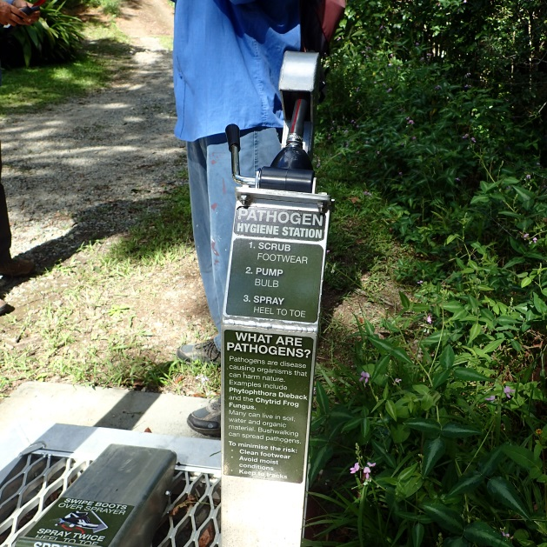

Tallebudgera Creek itself was nice and low, which made for relatively easy creek crossings - except for the treacherous veneer of condensation on the stepping stones outbound.

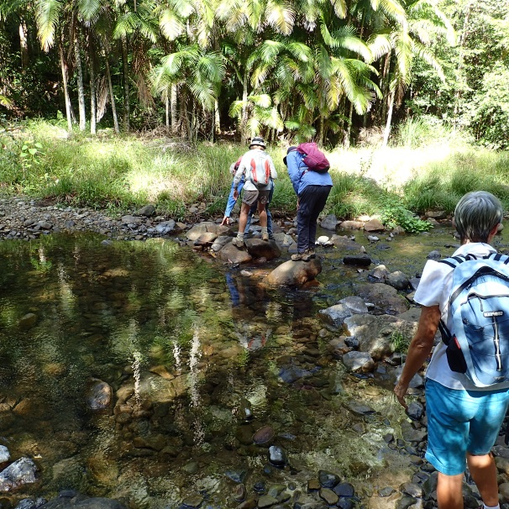
(2) as we ascended, at various points we still found a few voodoo plastic milk bottles, attached to posts and branches at head height, displaying the slogan 'Private property Keep out' capitalised in marker pen. Far from being a deterrent, these are actually quite helpful as they confirm we are on the right track - or wrong track, depending on your point of view ! Otherwise there is nothing whatsoever to guide an ascending walker on this section of the Cream Track.

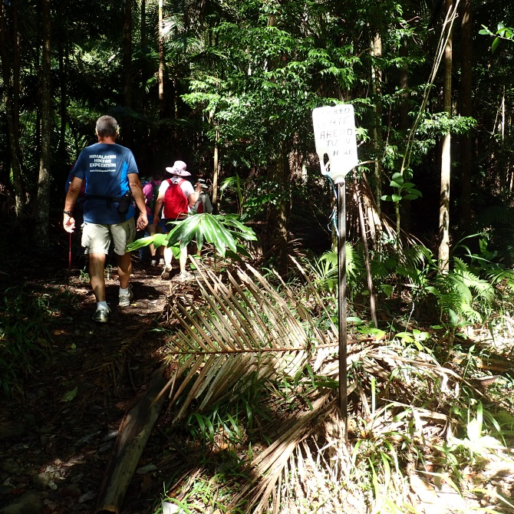
(3) Past the 4th (and last) Tallebudgera creek crossing we observed a prominent pink fluoro tape trail leading up the steep bank on our right (north) side. We discovered that this trail completely bypasses Lyndria Cook/Smith's first (lowest) pinch point (the locked gate) where the Track briefly crosses her property, by ignoring her kink in the graded road and resolutely following the ridgeline along a remnant of old logging track within the road reserve many metres above the gate.

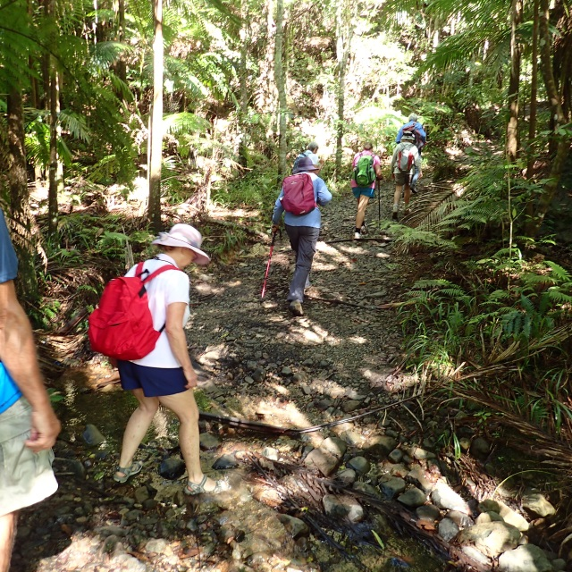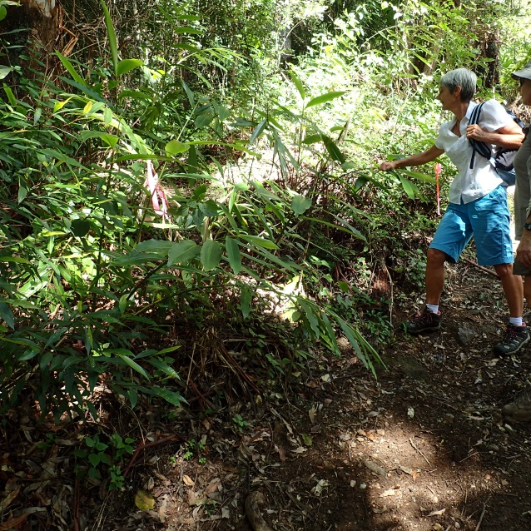

It emerges back onto the graded road at the cleared patch of grass on the 90 degree bend on the eastern corner of Harley Smith's banana plantation block.
This is an extensive detour through bush off of the graded road just to bypass the tiny incursion where LC's gate is sited. At neither end of the bypass is there any indication that a walker should take it or why.

(4) Back on the graded road to the top of the next short straight stretch is the Y junction at elevation 220 M where the prominent (right) branch goes into the heart of HS's banana plantation and the slightly less prominent (left) branch is the Cream Track which will soon deviate off the road reserve to form the 2nd (and more extensive) incursion onto LC land. This junction must have seduced many an ascending casual walker away from the Cream Track road reserve. We are looking out for fluoro tape and sure enough, we spot a fresh (not flesh !) pink trail leading up in between the two forks to neatly bypass this 2nd incursion onto LC land.
Sadly the fluoro tape trail is sparse in parts, especially above the large fallen tree - we enhanced it.

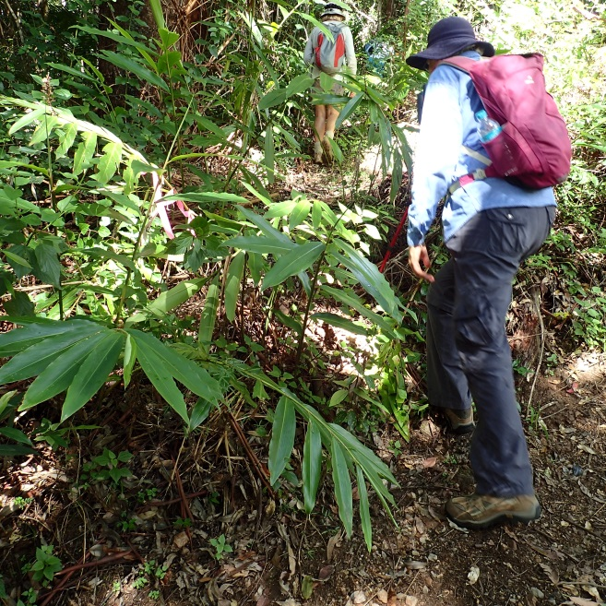

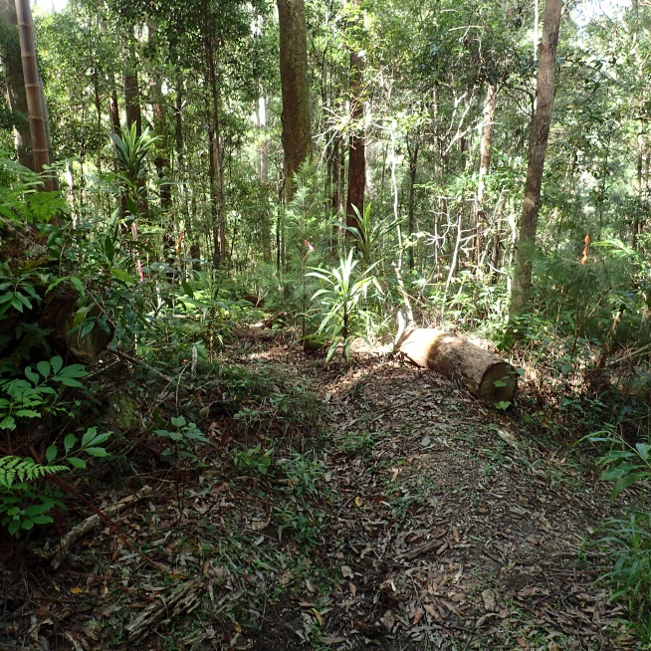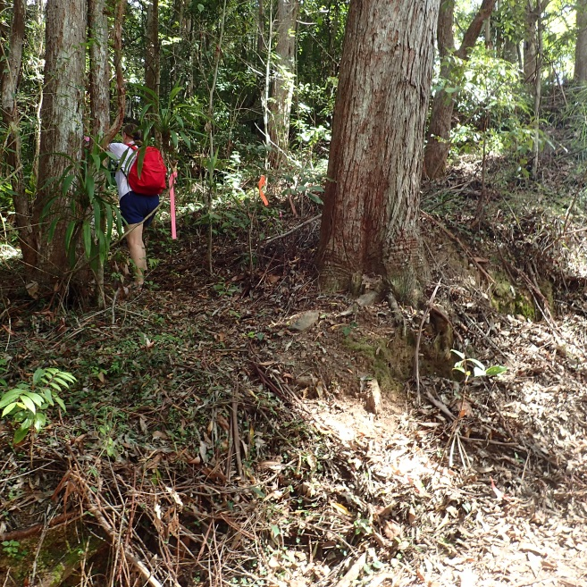

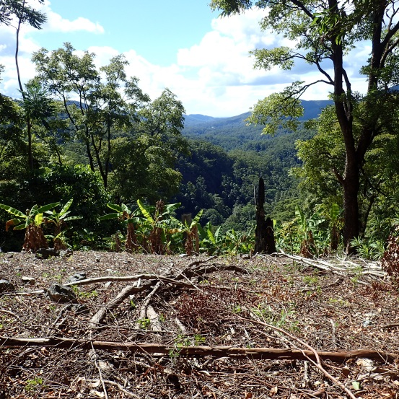

(5) Back on the graded road again at elevation 270 M we are immediately offered a v short fluoro'd diversion on the south side, presumably to avoid a possible incursion into the far SE corner of HS's banana plantation block. This diversion is not, in our view, strictly necessary as the graded road stays faithful to the C T road reserve round this bend.

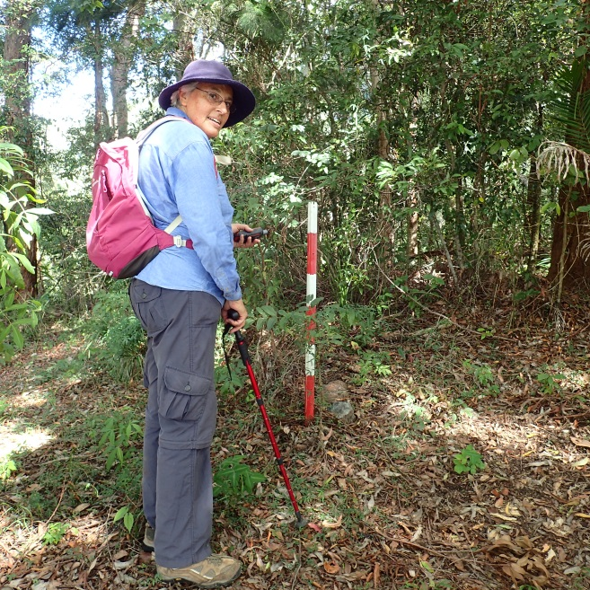

(6) Onwards up the graded road passing between the HSBP block and LC land, at elevation 350 M another fluoro'd diversion appears on the south side offering a trail up along the ridgeline for about 200 M before dropping back onto the graded road. Again, this diversion was not, in our view, strictly necessary as the graded road stays faithfully within the C T road reserve along this stretch.

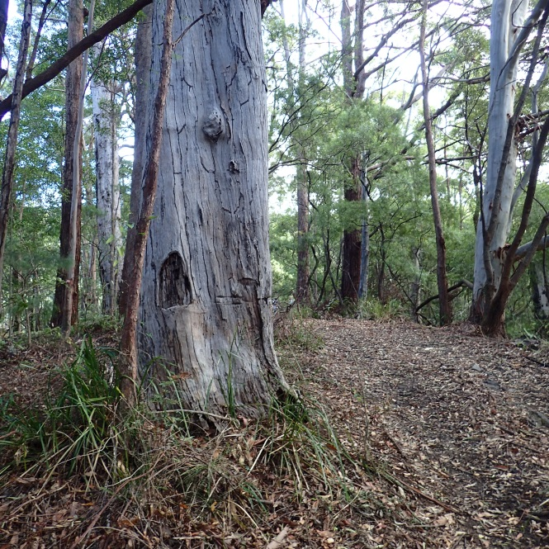

(7) Only a little further and we meet the 3rd (and last) private property incursion - this one transgresses the HSBP block - so at elevation395 M yet another fresh fluoro'd trail marks a several hundred metre diversion on the south side to keep the casual walker firmly within the C T road reserve. This fluoro section ends at elevation 440, there is no more graded road surface - here the CT is bounded by National Park on the south side and on the north side, the last short stretch of the HSBP block - helpfully marked by a final voodoo plastic milk bottle. As the CT climbs away from that last private property there appears to be no fluoro tape to assist the upward walker - though the trail is fairly distinct.
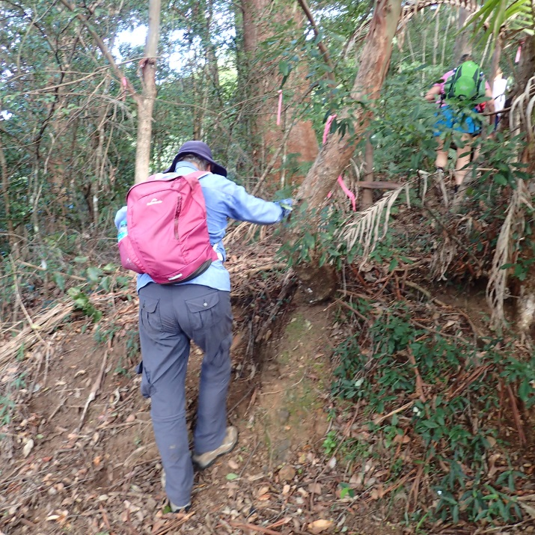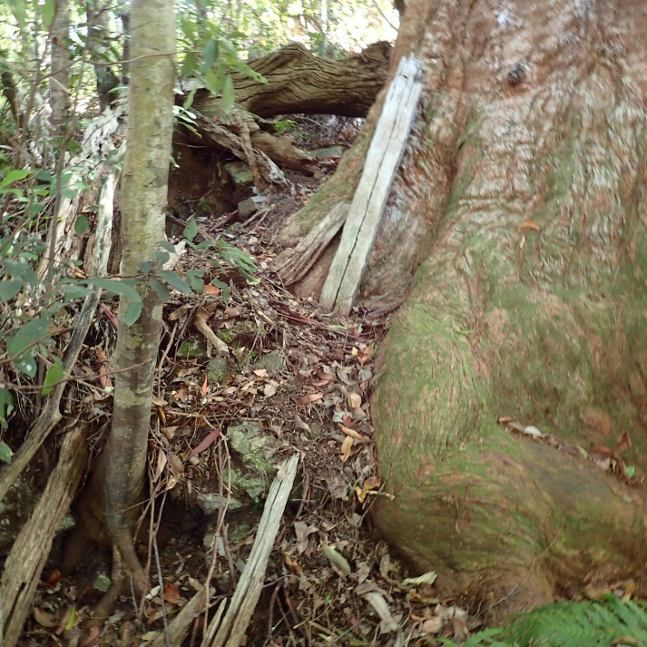

I'm confident that anyone could now walk this lower half of the Cream Track without fear of committing an inadvertent trespass - but some official CT signs and marker posts would be very useful, to reinforce the new diversions.
PS In dry conditions we picked up a surprising number of leeches and a couple of ticks.

